2006 IECC

Air Sealing Guide
for
Utah Residences



Table of Contents

Introduction 3

2006 IECC Code Definitions 5

Building Envelope 8

Major Contributors to Air Leakage 9

Sealing Unwanted Air Leakage Areas 11
Duct System 11
Windows & Doors 13
Special Applications 14

Other Sources of Air Leakage 15
Attics & Kneewalls 15
Exterior Walls 16
Framing Between Levels 17
Vented Crawl Space Areas 18
Basements 19

Materials for Sealing Air Leaks 20
“What to Use Where” Usage Chart 22

Safety Information 26

INTRODUCTION

In Utah, (effective January 1, 2007), the 2006 International Energy Conservation Code (IECC) has been adopted as the minimum level of energy efficiency a residential dwelling can be built. All individuals and organizations that desire to build residential dwellings in the state of Utah are required to show compliance with this energy code.

One of the basic premises of this building code deals with air infiltration and leakage rates. This is an area of the code that must be addressed and compliance shown through plan reviews as well as on-site visual inspections. The IECC has a very small section dealing with Air Leakage (IECC 402.4). It reads (in part):
402.4.1 Building Thermal Envelope: The building thermal envelope shall be durably sealed to limit infiltration. The sealing methods between dissimilar materials shall allow for differential expansion and contraction. The following shall be caulked, gasketed, weatherstripped or otherwise sealed with an air barrier material, suitable film or solid material:
- All joints, seams and penetrations.
- Site built windows, door, and skylights.
- Openings between windows and door assemblies and their respective jambs and framing.
- Utility penetrations.
- Dropped ceilings or chases adjacent to the thermal envelope.
- Knee walls.
- Walls and ceilings separating a garage from conditioned spaces.
- Behind tubs and showers on exterior walls.
- Common walls between dwelling units.
- Other sources of infiltration.
402.4.2 Fenestration Air Leakage: Windows, skylights and sliding glass doors shall have an air infiltration rate of no more than 0.3 cfm per square foot (1.5 L/s/m²), and swinging doors no more than 0.5 cfm per square foot (2.6 L/s/m²), when tested according to NFRC 400 or AAMA/WDMA/CSA 101/I.S.2/A440 by an accredited, independent laboratory and listed and labeled by the manufacturer.
Exceptions: Site-built windows, skylights and doors.

Other than the above stated guidelines the code provides no specific directions or guidance except through individual interpretation and suggestion(s) by other builders and/or the local building officials. The purpose of this Guidebook is to provide some direction and guidance specific to air sealing and leakage in new construction; to clarify where air leaks occur, how to limit air leakage, and what materials should be used to seal against air leakage. It is by no means an exhaustive document on the subject of air leakage or air sealing. It has been designed in a straightforward manner detailing the basics of the components of the 2006 IECC and the related compliance issues as well as to provide suggestions that can be used by building officials when performing a site visit on a newly constructed residential dwelling.

The Utah Energy Conservation Coalition wishes to acknowledge and thank the U.S. Department of Energy Special Energy Projects Program (Grant # DE-FG48-05R807011) as well as the Utah Department of Natural Resources Utah Geological Survey (Contract # 05-1014) for their financial support, direction and patience in the development of this document. Without this financial support the Utah Energy Conservation Coalition would not have been able to continue our goal of building and strengthening the relationships existing in the building and housing industries.

2006 IECC Code Definitions:

The 2006 IECC defines ‘Infiltration’ as:
The uncontrolled inward air leakage into a building caused by the pressure effects of wind or the effects of differences in the indoor and outdoor air density or both.

Under the ‘Residential Energy Efficiency’ Chapter the 2006 IECC states:

  - Air LEAKAGE (Mandatory)
402.4.1 Building Thermal Envelope. The building thermal envelope shall be durably sealed to limit infiltration. The sealing methods between dissimilar materials shall allow for differential expansion and contraction. The following shall be caulked, gasketed, weatherstripped, or otherwise sealed with an air barrier material, suitable film or solid material:
- All joints, seams and penetrations.
- Site built windows, door, and skylights.
- Openings between windows and door assemblies and their respective jambs and framing.
- Utility penetrations.
- Dropped ceilings or chases adjacent to the thermal envelope.
- Knee walls.
- Walls and ceilings separating a garage from conditioned spaces.
- Behind tubs and showers on exterior walls.
- Common walls between dwelling units.
- Other sources of infiltration.

402.4.2 Fenestration Air Leakage. Windows, skylights and sliding glass doors shall have an air infiltration rate of no more than 0.3 cfm per square foot (1.5 L/s/m²), and swinging doors no more than 0.5 cfm per square foot (2.6 L/s/m²), when tested according to NFRC 400 or AAMA/WDMA/CSA 101/I.S.2/A440 by an accredited, independent laboratory and listed and labeled by the manufacturer.
Exceptions: Site-built windows, skylights and doors.

402.5 Moisture Control (Mandatory). The building design shall not create conditions of accelerated deterioration from moisture condensation. Above-grade frame walls, floors and ceilings not ventilated to allow moisture to escape shall be provided with an approved vapor retarder. The vapor retarder shall be installed on the warm-in-winter side of the thermal insulation.
Exceptions:
- In construction where moisture or its freezing will not damage the materials.
- Frame walls, floors and ceilings in jurisdictions in Zones 1 through 4 (Crawl space floor vapor retarders are not exempted.)
- Where other approved means to avoid condensation are provided.

While this information has been streamlined and simplified from previous editions of the IECC and seems to be straight forward, the Coalition has found that these requirements to reduce air leakage need some additional explanation of terms, details, and materials as applied to all residential construction in the state of Utah. This Air Sealing Guide has been designed to provide that additional explanation and detail in a manner that will allow the reader a greater ease in understanding the code and in applying air sealing energy efficient building practices to the residential dwellings being constructed in the state of Utah.

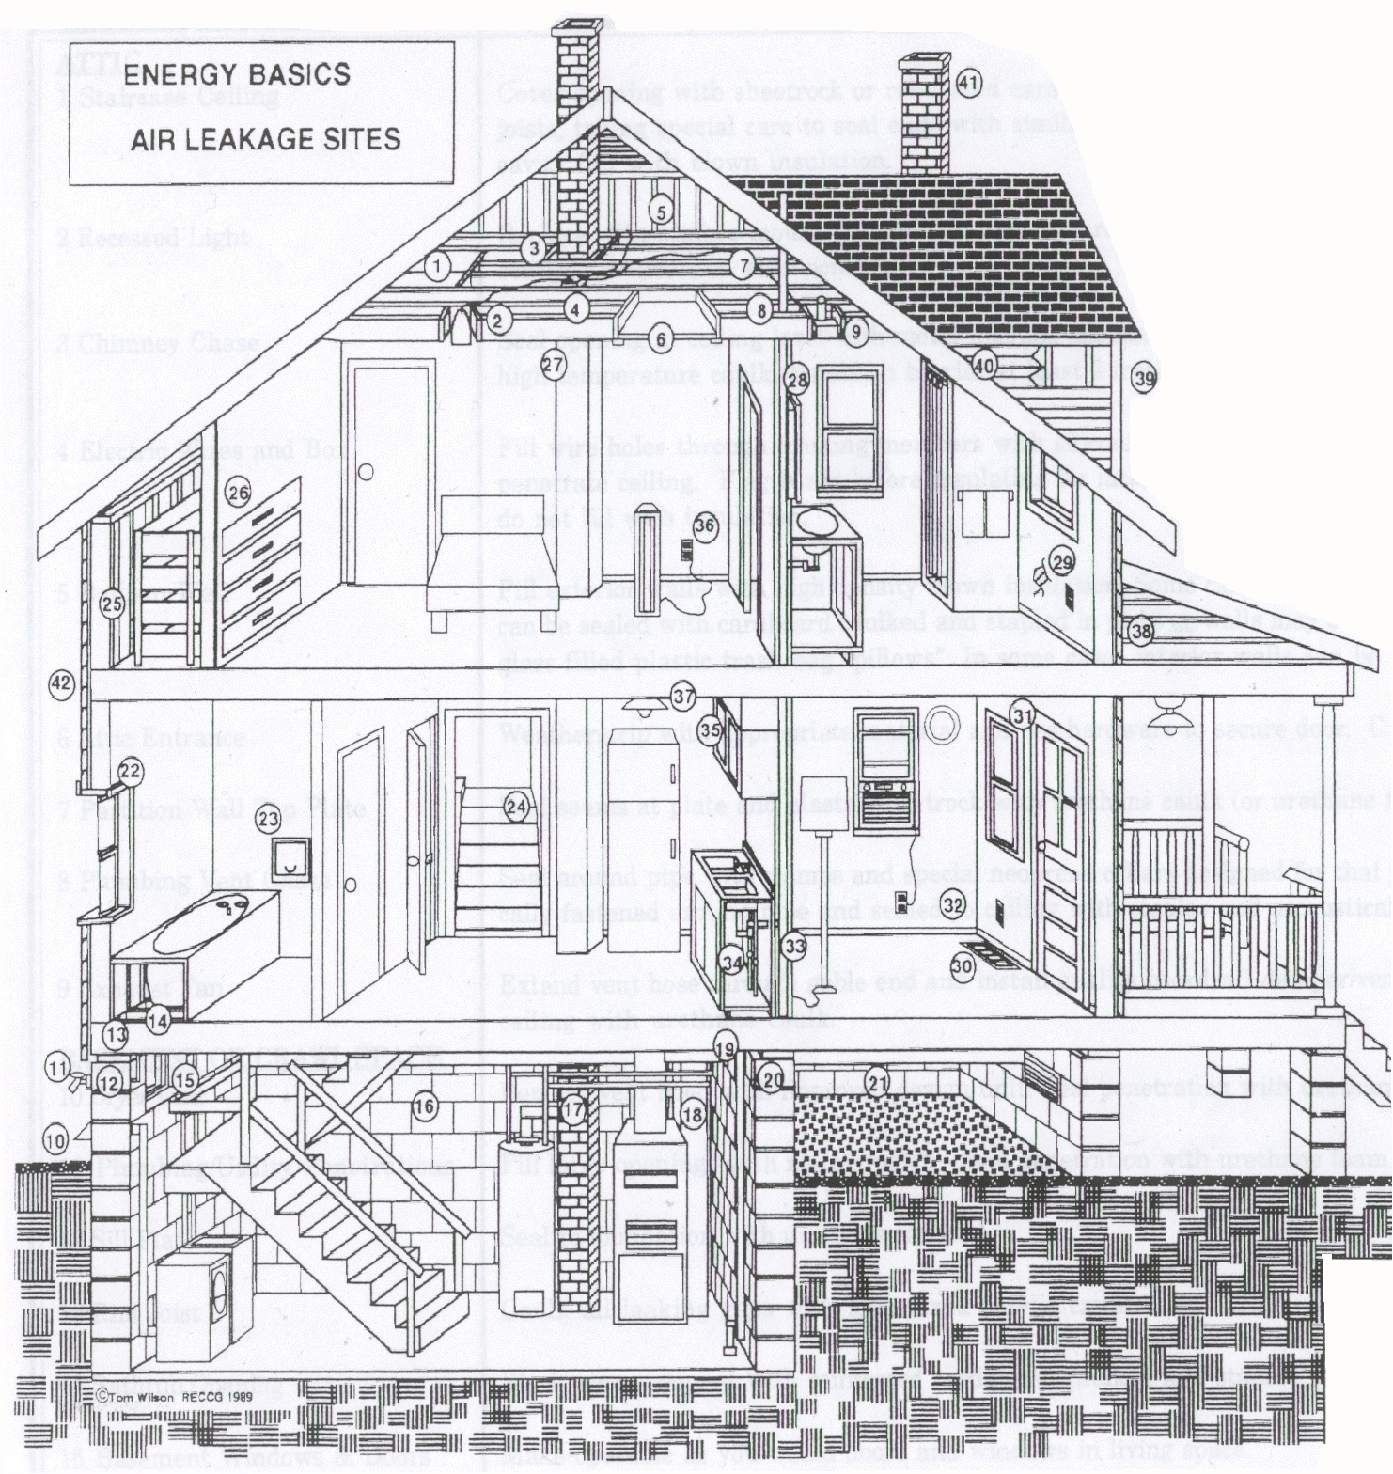
1 Dropped ceiling
2 Recessed Light
3 Chimney Chase
4 Electric Wires & Box
5 Balloon Wall
6 Attic Entrance
7 Partition
8 Plumbing Vent Chase
9 Exhaust Fan
10 Dryer Vent
11 Plumbing/Utility Penetrations
12 Sill Plate
13 Rim Joist
14 Bathtub Opening
15 Basement Windows & Doors
16 Block Wall Cavities
17 Water Heater/Furnace Flue Connections
18 Ductwork
19 Plumbing Chase
20 Basement & Crawlspace leakage
21 Floor Boards
22 Window Sashes & Doors
23 Laundry Chute
24 Stairwell
25 Kneewell/Framing Intersection
26 Built-in Dresser
27 Chimney Penetration
28 Built-in Cabinet
29 Holes in Plasterwalls
30 Furnace registers
31 Window & Door Frames
32 Baseboards, Coves & Interior Trim
33 Plumbing Access Panel
34 Sink Plumbing Penetration
35 Dropped Soffet
36 Electrical Outlet
37 Electrical Fixture
38 Porch Framing Intersection
39 Missing Siding or Trim
40 Additions, Dormers & Overhangs
41 Unused Chimney
42 Floor Joist
The Building Envelope:

The building envelope is the insulated boundary between the conditioned space inside the home and an unconditioned attic, basement, crawlspace, garage, or outside. Sheetrock, wood framing, exterior wall sheathing, foundations and sub-flooring may all be considered to be elements of the building envelope. When we look at air leakage issues and infiltration concerns in a residential dwelling, it is at the joints, cracks, penetrations, and holes in these various materials and locations that we are mainly concerned with during the construction process.

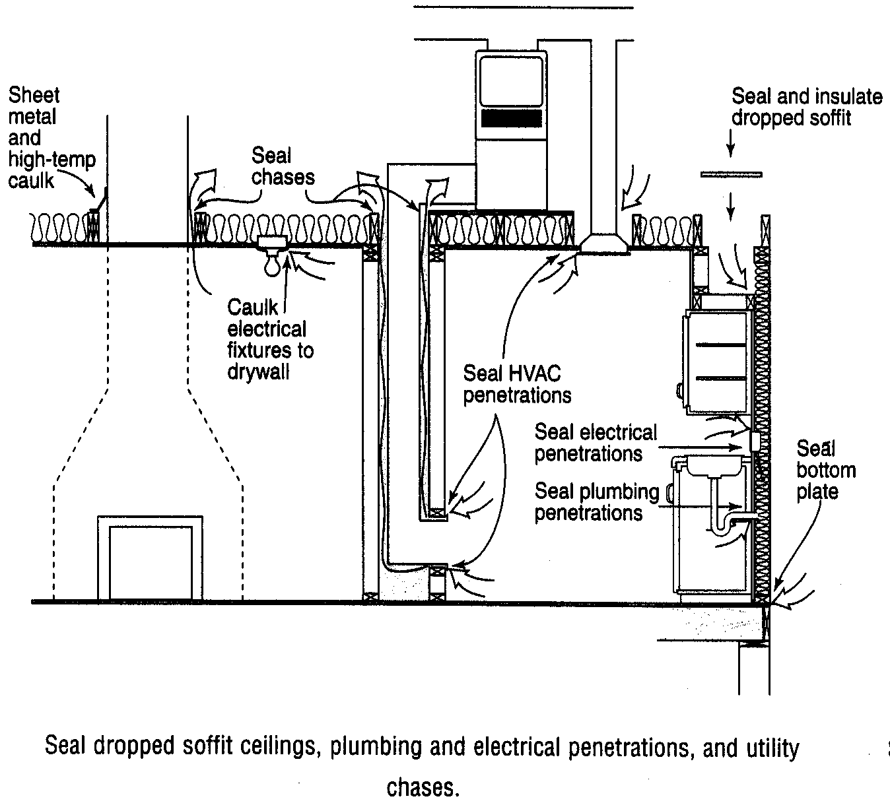

Major Contributors To Air Leakage:

The building envelope has many joints and seams that need to be addressed in limiting and reducing the air leakage in a residential dwelling. Field testing on residential structures in Utah has shown that doors, windows, and HVAC systems alone can account for over 1/3 of all air leakage in a home.

In a series of field tests nationwide, the Lawrence Berkeley Laboratories found that homes with and without standard open flue fireplaces had air leakage occurring through the following components:

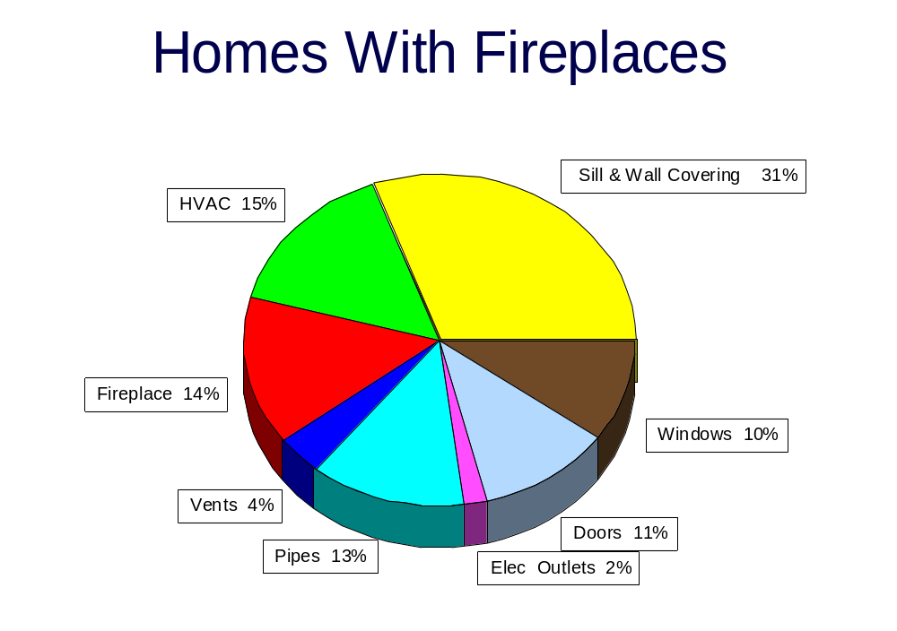
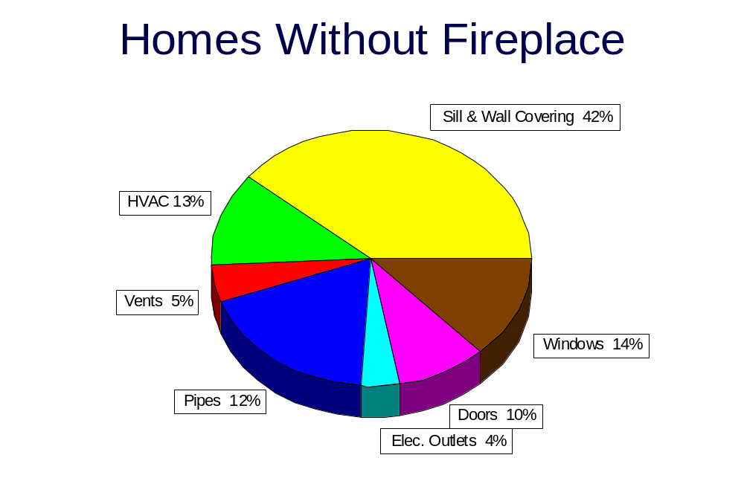
Some other areas of general concern when dealing with air leakage would be:

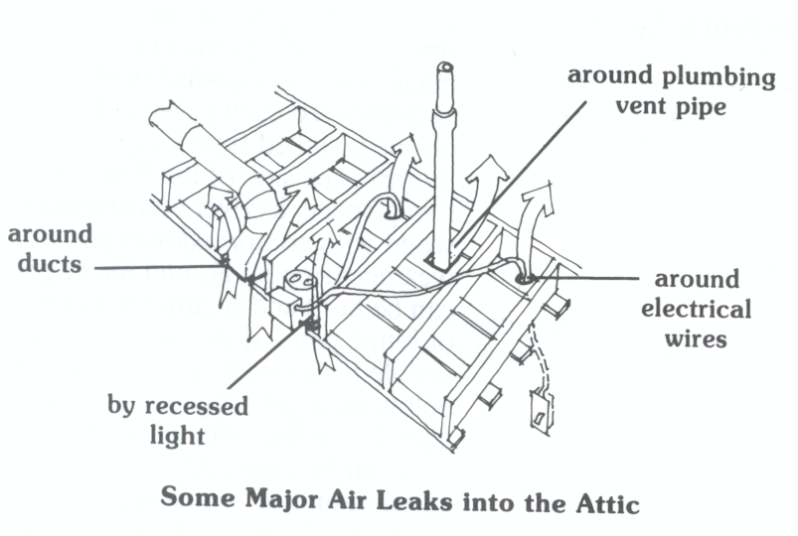
- Attic Leakage

- Electrical Wire Penetrations

- Recessed Light

- Dryer Vent

- Ductwork

- Window and Door Frames

- Plumbing Penetrations
Sealing Unwanted Air Leakage:

Any sealing and or controlling of air leakage in a residential building should begin with the paying strict attention to the following major building components:

Duct Systems

Heating and cooling air duct distribution systems are an important part of the building envelope. Where ducts are located in unconditioned spaces, such as crawl spaces, garages, attics, or basements, air can leak out of supply ducts, or leak into return ducts at joints and seams in the ductwork.

The 2006 IECC addresses duct construction and sealing (specifically for small commercial buildings but with a direct application to residential construction and inspection) in Section 503.2.7. It reads (in-part) as follows:

503.2.7 Duct & plenum insulation and sealing. All supply and return ducts and plenums shall be insulated with a minimum of R-5 insulation when located in unconditioned spaces and with a minimum of R-8 insulation when located outside the building. When located within a building envelope assembly, the duct or plenum shall be separated from the building exterior or unconditioned or exempt spaces by a minimum of R-8 insulation.
All joints, longitudinal and transverse seams and connections in ductwork, shall be securely fastened and sealed with welds, gaskets, mastics (adhesives), mastic-plus-embedded-fabric systems or tapes.
503.2.7.1.1 Low Pressure duct systems. All longitudinal and transverse joints, seams and connections of supply and return ducts operating at static pressures of less than or equal to 2 inches w.g. (500Pa) shall be securely fastened and sealed with welds, gaskets, mastics (adhesives), mastic-plus-embedded-fabric systems or tapes installed in accordance with the manufacturer’s installation instructions.

For the purposes of sealing the building envelope, any joint between mechanical systems, ducts, transitions and boots must be sealed. Any seam in a component must also be sealed against air leakage. Both supply and returns outside of the conditioned space are considered a part of the building envelope.

Returns that use wall or floor framing must be sealed against the entry of air. Closures on the bottom of floor joists should be sealed with appropriate materials, and joists around the cavity edges should be caulked or otherwise sealed. Wall cavities should be blocked above entry grilles (see Illustration).

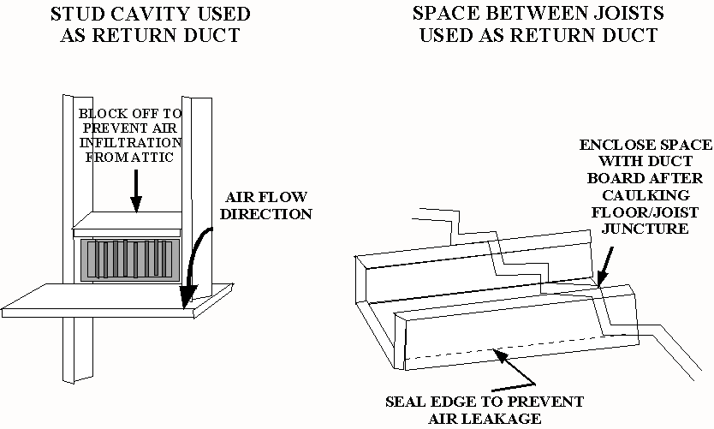
Windows And Doors

Another major source of air leakage in the building envelope is the movable joint around doors and windows. These cracks vary by window design and type of operation.

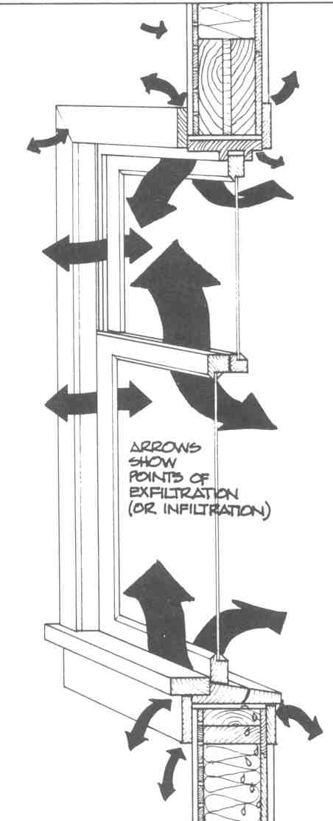
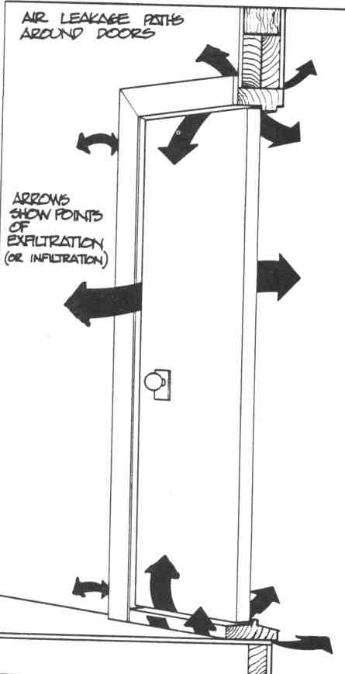
Special Applications

Other penetrations in the building envelope that must be sealed to limit air infiltration are:

Fireplace - Whether built on site or factory made, a fireplace must have an operating and tight-fitting flue damper, or air-tight doors.

Exhaust Vents - Exhaust fans, clothes dryer outlets or other vents, the discharge at the exterior must have a tight damper closure.

Pull-down Stairs – Many attic access openings that have built-in steps must be weather-stripped or gasketed, or covered in the attic with an enclosure.

Whole-house Fans - Louvered openings for whole-house fans must have a positive means of closure, and must be designed to limit air leakage.

Kneewall Cavities - Wall cavities of kneewalls need a closure or a cover on the attic side; use sheathing or housewrap to stop air leakage.
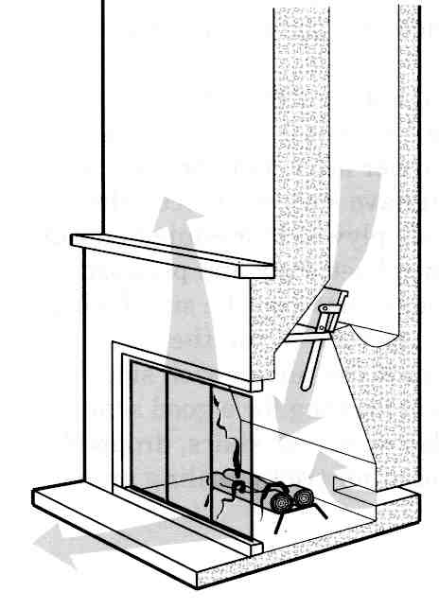
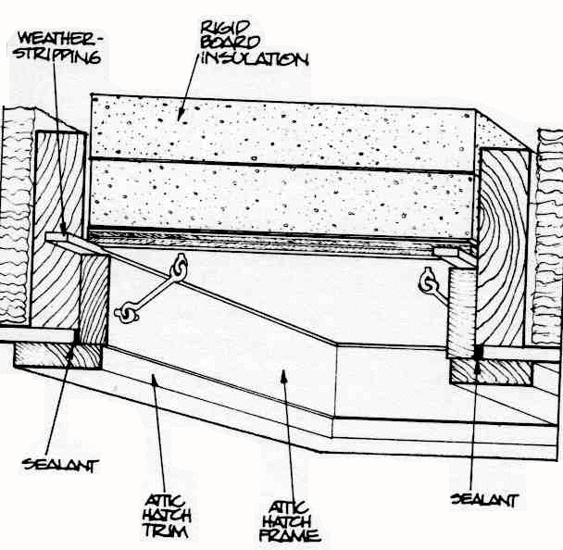
Damper
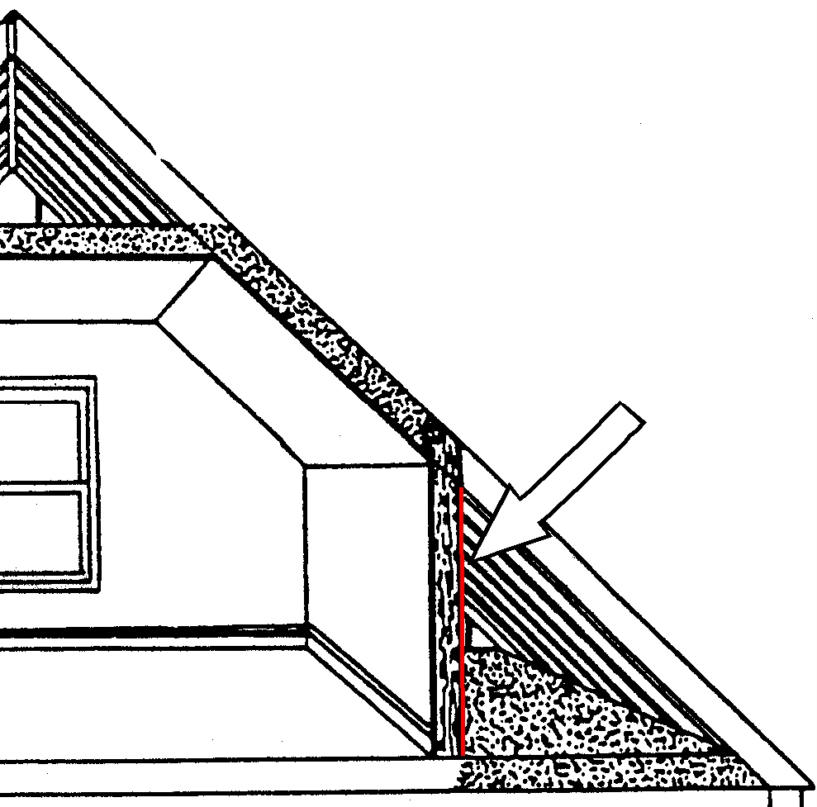
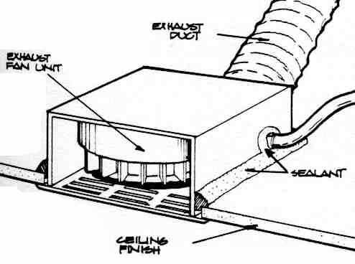
Air barrier on attic side

OTHER SOURCES OF AIR LEAKAGE THAT MAY OCCUR IN A HOME:

It is important to seal and address all air leakage paths wherever they may occur in a residential building. Each portion of a home has its own set of joints and penetrations that contribute to leakage of the building envelope. The following building element descriptions identify where these joints may occur.

Attics and Kneewall Areas

The places to look for sources of air leakage in attic areas include:

- Drop soffits, drops above tub/shower units and framing above stairwells
- Edges of access doors to attics and through kneewalls
- Penetrations through wall top plates
- Recessed light fixtures and gaps with the ceiling
- Interior wall and ceiling joint, between top plate and wall finish
- Interior chase wall gaps at the ceiling, or at chimneys, flues or stack penetrations through ceilings.
- Fan vent exhausts, and the connection between the unit and ceiling
- Discontinuous ceiling finishes, such as drop ceilings and plank finishes
- Attic access door joint with wall finish
- Kneewall framing area between bottom plate and subfloor
- Floor framing gaps below kneewall
- Joint between register boot and sheetrock
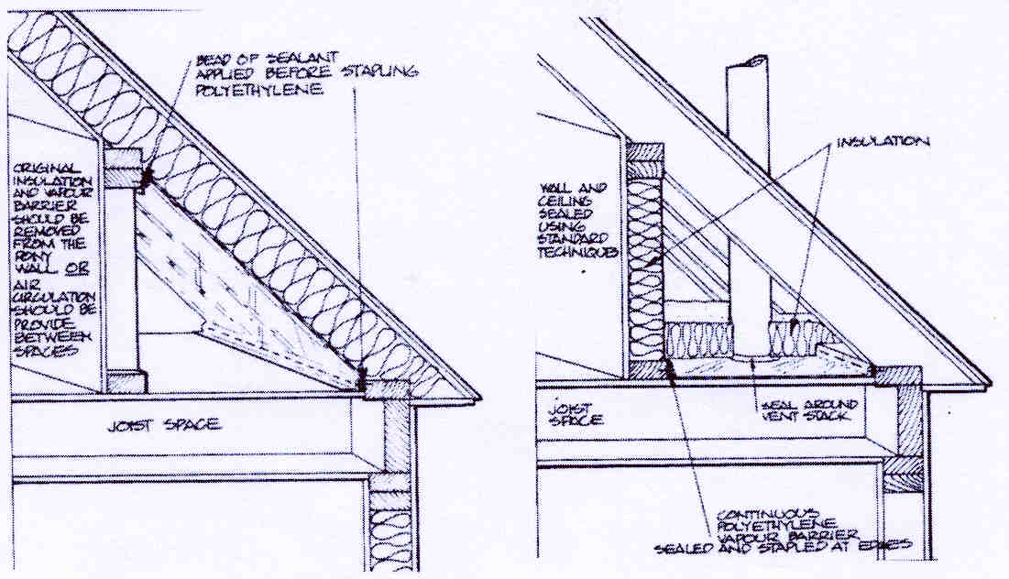

Exterior Walls

The places to look for sources of air leakage in exterior walls include:

- Framing joints between double top plates
- Penetrations through wall top and bottom plates
- Around window and door units and the rough framing
- Electrical distribution boxes in exterior walls
- Area around exhaust vent and the sheathing
- Utility entry through the wall
- Sheathing joints, especially those not backed up by framing
- Framing joints at wall corners, and framing joints at the intersection of interior and exterior walls
- Framing joints between the wall bottom plate and subfloor
- Behind tub/shower units
- Bolts securing seal plates
- All four sides surrounding rim/band joist areas
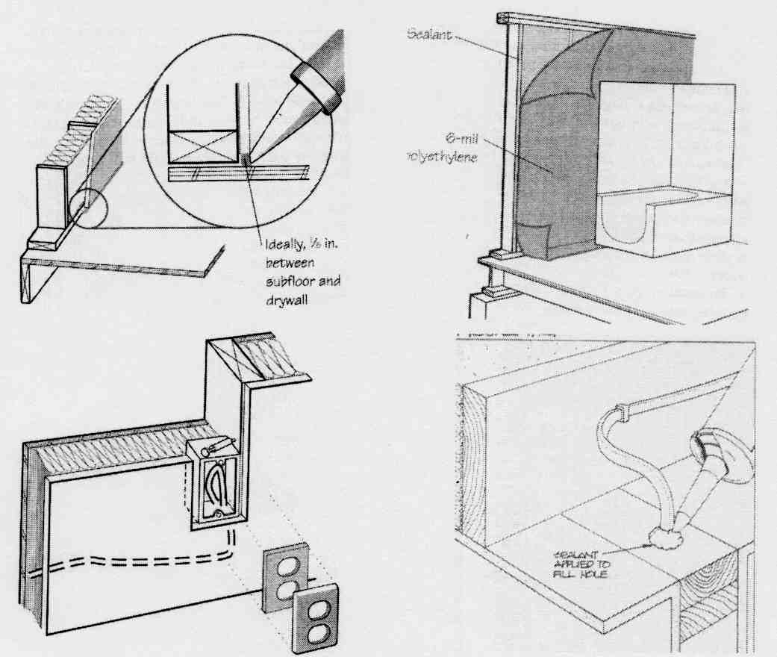
Framing Between Levels

The places to look for sources of air leakage in a two-story or multi-level residence include such areas as:

- Area between exhaust vent and sheathing
- Framing joint between band joist and wall top plate
- Drop soffit areas
- Framing joints between sub-floor and rim/band joist
- Cantilevered floor framing joints

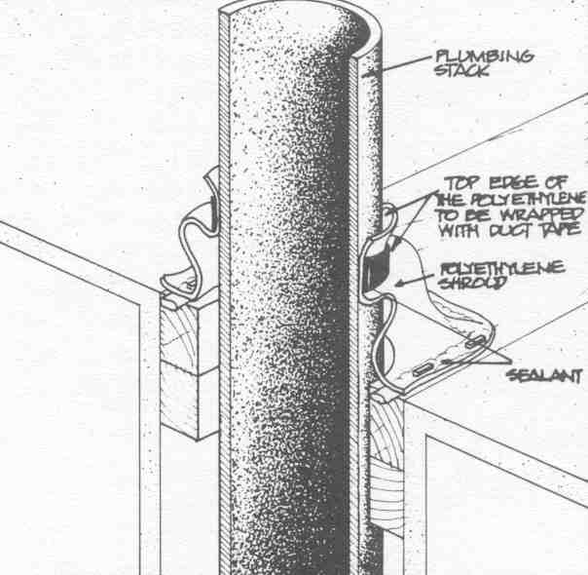
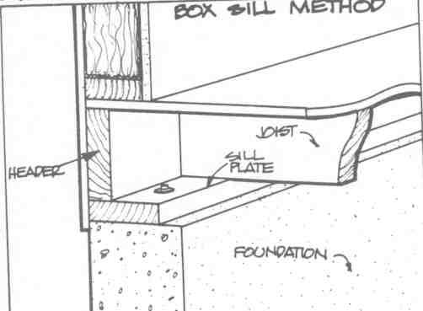
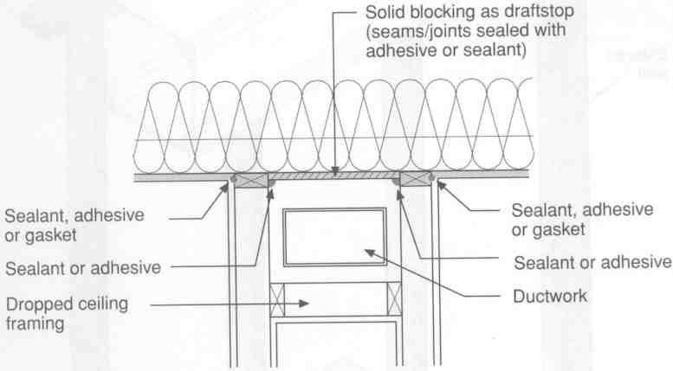
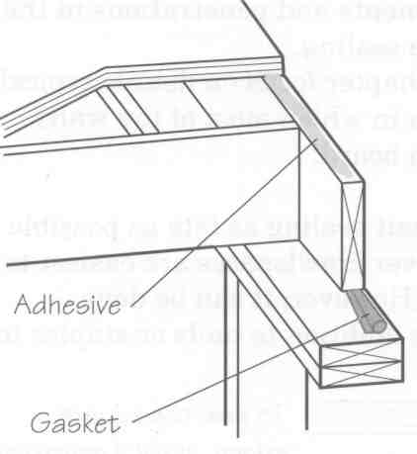
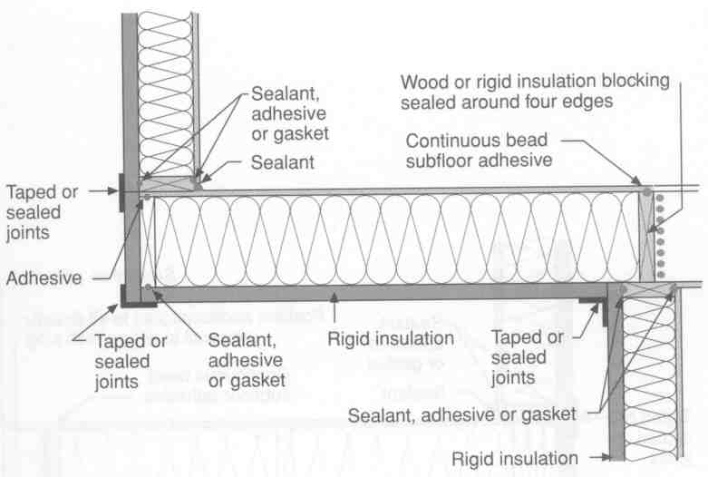
Vented Crawl Spaces

The places to look for sources of air leakage in any vented crawl space area may be located in such areas as:

- Plumbing penetrations through sub-floor
- Gaps between exhaust duct and sub-floor

- Interior chase wall gaps in the sub-floor
- Connection between register boots and sub-floor
- Wiring penetrations

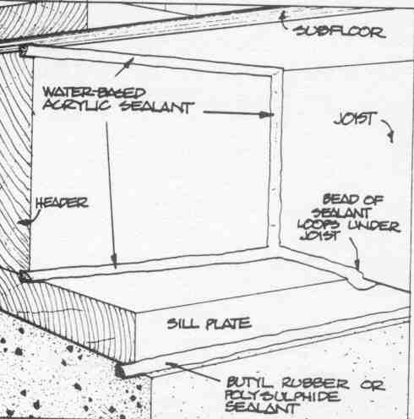
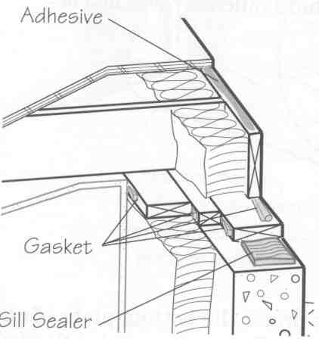
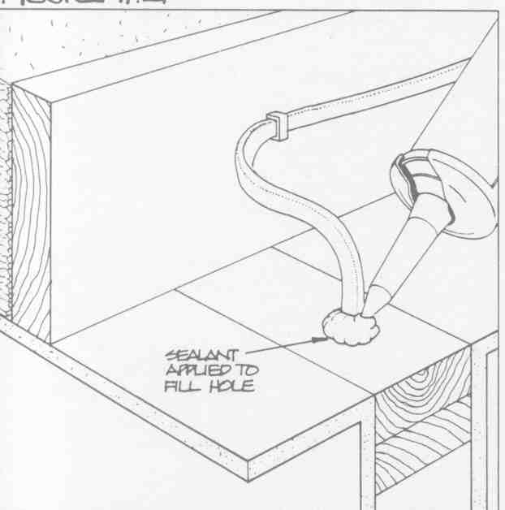
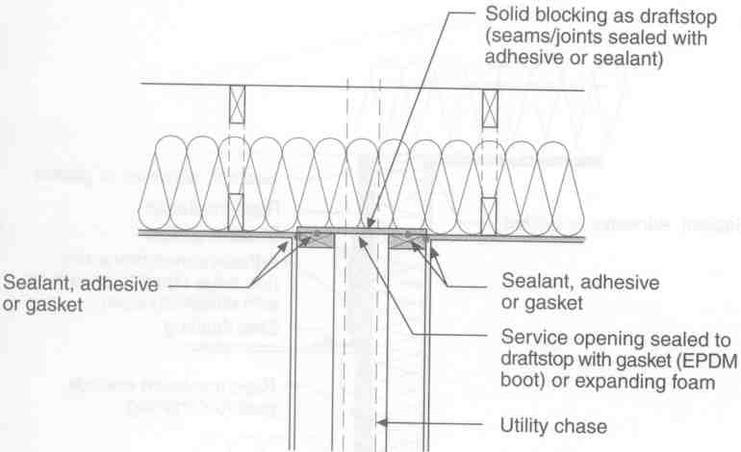
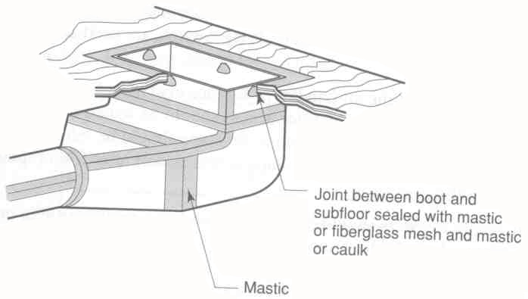
Basement

The places to look for sources of air leakage in a basement area may include:
- Framing joint between subfloor and band joist
- Cantilever floor framing joints
- Joint between foundation and sill plate
- Utility entry (pipes and wires) through the band/rim joist or foundation
- Framing joint between band/rim joist and sill plate
- Around window and door units and foundation
- Gaps between exhaust vent and sheathing

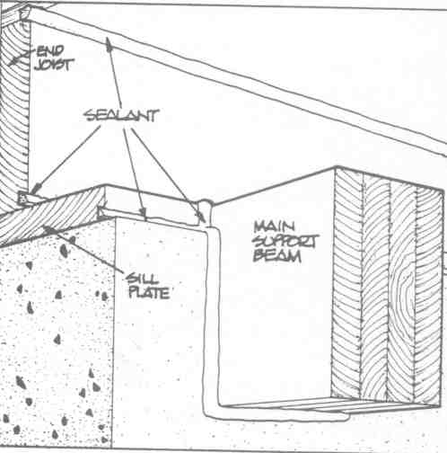
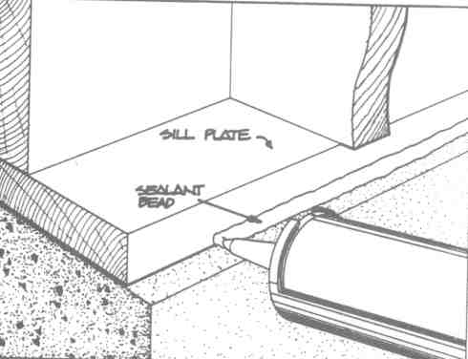
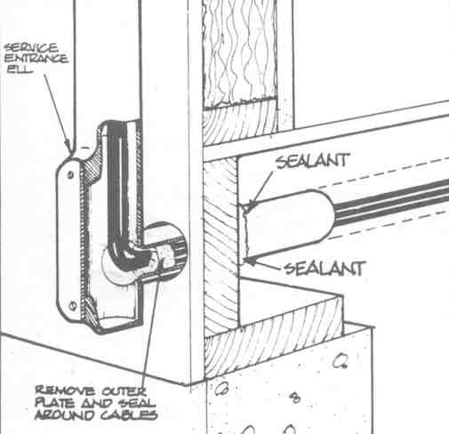
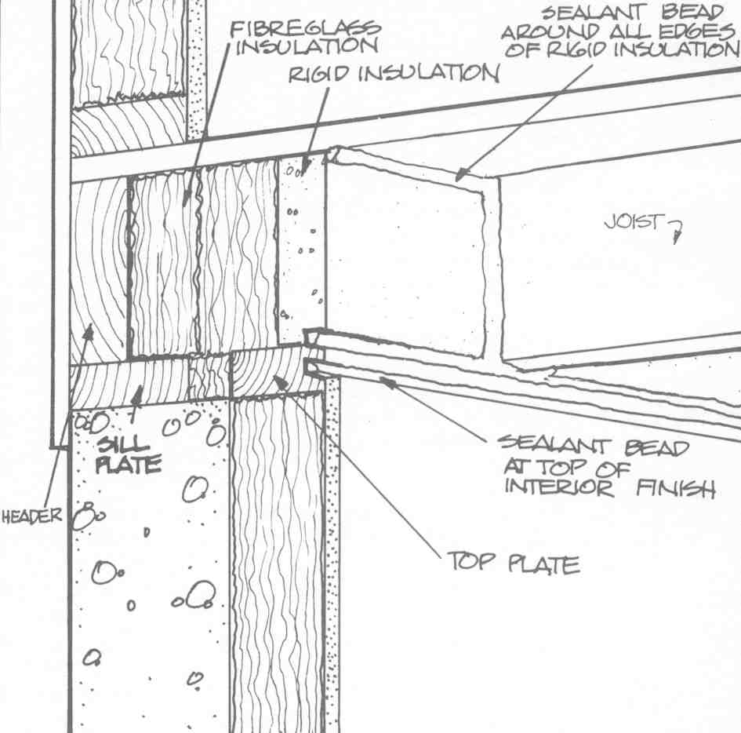

Materials for Sealing Air Leaks

There are many different materials that can be used in sealing the sources of air leakage, including caulks, foam sealants, house wraps, gaskets, and even wood framing for blocking large gaps in construction.

The most important feature of any sealant is its permanency. For example, if a caulk is used to cover a joint, air will eventually leak around it if it shrinks, cracks, or falls out of the joint. Shrinkage of framing members from drying will also place additional stresses on these areas. Since many of the openings in construction will be closed up or covered during construction, it is imperative that the right materials be used to assure the long-term blocking of air leakage.

Sealants
A sealant is any flexible caulking that adheres to most construction materials, will withstand minor movement of the materials, and will remain flexible for at least 10 years. Materials meeting ASTM C 920 will meet these requirements, and are considered acceptable sealants.

Polymeric Foams
A special form of sealant is a polymeric foam, which is designed to adhere to most construction materials, fill the volume of a crack or space, and last for the life of the building when properly installed and protected from weather (only to be used on the interior). Materials specifically labeled for construction joint closure should be used.

Construction Adhesives
For certain joints a quality construction adhesive may be used, as long as it adheres to the materials being bonded, and retains it structure over the life of the building. Adhesives meeting ASTM C 557 will meet these requirements, and are considered acceptable adhesives.

Housewraps
A housewrap is usually sheet material(s) that can be applied to the exterior of a wall assembly. It covers most construction joints and seals them against air leakage. A housewrap must be permeable; it must be stabilized against ultra-violet radiation; and it must limit air flow. Some housewraps can provide weather resistance for brick, masonry, or stucco applications.

Gasketing
Gaskets are materials not permeable to air movement that are compressible, but will return to their original shape. This feature allows gaskets to be placed into joints or openings during construction, and expecting the joint to be closed against air leakage, even when framing materials shrink or move. There are no state specific standards for these materials. Common products are made of EDPM, impregnated foams, or polyurethane foams. Joints must be examined to be sure that any opening is completely filled. This may require the additional use of sealants or polymeric foams where gaps still exist.

Tapes and Mastics
Joints in sheathings, house wraps, or vapor retarders may be closed with tapes, when the right tape is used. The sheathing, housewrap, or retarder manufacturer’s recommendations should be followed for a tape that permanently bonds to the materials, has a high tack, and is compatible with the surface. Certain tapes (tapes with mastic or fibrous backing or in compliance with UL 181 A or B) are to be used on dust systems.

Blocking
Some portions of the building envelope are not closed, and can have large openings that allow air to leak into and out of the building. Solid blocking, such as wood framing, plywood or duct board must be installed and secured in place to seal these openings. Around hot objects, such as flues or metal chimneys, metal fire stops may be required.

Fire Stopping
Penetrations and other openings through a floor, wall partition, shaft enclosure, floor/ceiling assembly, or roof/ceiling assembly shall be sealed to prevent the passage of fire and smoke. The material used to fill these openings shall be capable of providing equivalent fire resistance to code listed materials, as determined by ASTM E 814, ASTM E 119 or UL 1479 in similar application.

Other Systems
Air leakage can be effectively controlled with the materials given above. While other approaches may be used, caution should be exercised. Any claims of “blocking air infiltration” should be considered marketing hype until solid scientific test data is provided. For example, some wall cavity insulation products claim to stop or block all air leakage through the wall. Testing of many cellulose and mineral fiber (glass and rockwool) insulations has shown these products minimize leakage, and none (yet) have been shown to completely stop air leakage. In addition, the largest sources of air leakage do not occur through the insulated wall cavity.

Usage Chart
“What to Use Where”

The following chart below and on the next few pages indicates where each type of air-sealing material should/could be used. Where several options for materials are given, select the one you feel best suits the situation and application that you are addressing.

 | Weatherstrip | Foam  Sealant | Gaskets | Dampers | House-wrap and Sheathing | Approved Tape Sealant or Mastic | Solid Blocking | Fire stops
Ductwork

Duct Joint Supply
Duct Joint Return
Windows & Doors

Window units moveable joint
Door units
moveable joint
Special Applications

Fireplaces
Exhaust Vents
Pull-down Stairs
Whole House Fans
Knee wall Framing

 | Weatherstrip | Foam Sealant | Gaskets | Dampers | House-wrap & Sheathing | Approved Tape Sealant or Mastic | Solid Blocking | Fire stops

Attic Areas

Attic Scuttle

Door Edges
Recessed Light Fixtures & Ceiling Joints
Penetrations Through Wall Top Plates
Interior Wall & Ceiling Joints (between top plate and wall finish)
Dropped Soffits & Framing Above Stairwells
Interior Chase (wall gaps at ceiling)
Chimneys, Flues, or Stack penetrations through ceilings
Fan Exhaust Vents (joints between register boots & ceiling)
Discontinuous Ceiling Finishes (drop ceilings)
Knee-wall Framing
Floor Framing (gaps between knee-walls)
Electrical Outlet joints & Wall Finishes
EXTERIOR WALLS
Around window/door units and framing
Penetrations - wall top & bottom plates
Electrical distribution boxes
Utility entry through wall
Sheathing joints, (not backed up by framing)
Joints at vent and sheathing
Joints between double top plates

 | Weatherstrip | Foam Sealant | Gaskets | Dampers |  | House-wrap & Sheathing |  | Approved Tape Sealant or Mastic |  | Solid Blocking | Fire stops
Exterior Walls Cont’d
Joint at exhaust
vents at sheathing
Joint at bottom plate
and subfloor
Framing joints and
wall corners
Framing joints at the intersection of interior and exterior walls
Behind tub/shower units
Floor Framing Between Stories
Joint at sub-floor and Rim/Band joist
Joint at Rim/Band joist and wall top plate
Joint at exhaust vent and sheathing
Cantilever Floor Framing Joints
Drop Soffits

Vented Crawl Spaces
Access Door Edges
Chases in wall gaps in the sub-floor
Plumbing Penetrations through sub-floor
Joint at exhaust duct and sub-floor
Joint at register boot and sub-floor
 | Weatherstrip | Foam Sealant | Gaskets |  | Dampers |  | House-wrap & Sheathing |  | Approved Tape Sealant or Mastic | Solid Blocking | Fire stops

Basement
At window and door units and foundation
Joint at foundation and sill plate
Joint between sub-floor and rim/band joist
Joint between rim/band joist and sill plate
Joint at exhaust vent and sheathing
Cantilever floor framing joints
Utility entry at band joist/foundation
Water pipes penetration through rim/band joist

Safety Information Associated With Air Sealing of Buildings

The following information is provided for reference to those individuals who will be responsible for the air sealing of buildings. Since houses are interactive systems, the reduction in air leakage may impact the health and safety of the building occupants. Some of these issues are already addressed in general by the 2006 IECC as well as the 2006 IRC, while others are simply recommended for consideration by industry groups such as the American Society of Heating, Refrigerating and Air Conditioning Engineers (ASHRAE), the American Lung Association (ALA), etc. Listed below are several different approaches for air sealing that might be considered as you plan the design and construction of your home.

There is a suggested ventilation rate of 0.35 air changes per hour, or 15 cfm per bedroom + 1 (if you don’t know the number of people) or 15 cfm per person (whichever is greater).
ASHRAE 62-1989 Standard-Ventilation for Acceptable Air Quality, Table 2.3, Residential Living Areas
The ventilation for a house is normally satisfied by infiltration and natural ventilation. Dwellings with tight enclosures may require supplemental ventilation supply for fuel burning appliances, including fireplaces and mechanically exhausted appliances.

Possible Solutions to Consider:
- Provide a continuous mechanical ventilation strategy.
- Measure the actual air leakage of the structure with a blower door. Use the factors of climate, height and exposure to modify the measured air flow and calculate an estimate of the natural ventilation rate.
- Seal the building envelope so that a blower door test will indicate a leakage rate no greater than 0.216 cubic feet per minute (cfm) per square foot of envelope area of the house with a pressure differential of 50 Pascals (Pa.) across the envelope. Install a continuous ventilation strategy.

Standard construction practices encourages an avoidance of negative or positive air pressures when interior doors are closed and the heating or cooling air handler blower turns on (pressure imbalances).

Possible Solutions to Consider:
- Provide an adequately designed and installed multiple return HVAC system.
- Provide adequately designed and installed air transfer grilles.
- Measure the actual air pressure differences across interior doors and across the building envelope while the interior doors are closed and the air handler blower is operating. Providing pressure relief until any area containing a fireplace, wood stove or combustion furnace, boiler or water heater is less than -3 Pa. of pressure differential with reference to the outside.

Related to residents’ overall comfort in any residential structure, builders should design and construction in such a manner as to avoid excessive negative air pressure during the operation of any combination of devices that exhausts air from the building.

Possible Solutions to Consider:
- Avoid the installation of atmospheric draft combustion appliances within the conditioned space, unless the ventilation systems have been designed to accommodate their operation.
- Measure the actual air pressure differences in an area containing an atmospheric venting appliance and in the vent on the appliance. While operating the air handler blower with interior doors closed and all exhaust devices turned on, provide pressure relief until any area containing an atmospheric venting appliance is less than -3 Pa. of pressure differential with reference to outside.
- Additionally confirm that the following vent draft guidelines are met (see next page).

Outdoor Temperature Draft Pressure
Less than 20 F -5.0 Pa.
20 F to 40 F -4.0 Pa.
40 F to 60 F -3.0 Pa.
60 F to 80 F -2.0 Pa.
80 F or greater -1.0 Pa.

In light of increased allergic reactions and ‘hyper-sensitivity’ of various individuals (as well as a growing desire to use sustainable building components) builders should take into consideration the avoidance of construction materials and building designs that may contribute to indoor air pollution.
(ASHRAE 62-1989 Standard - Ventilation for Acceptable Indoor Air Quality)

Possible Solutions to Consider:
- Give careful consideration to the materials that you use throughout the construction process.
- Install intermittent ventilation systems that operate quietly, effectively and are ducted completely outside the structure.
- As an additional safety feature, measure the actual concentrations of Carbon Dioxide, Chlordane, Ozone and Radon gas. In particular, Carbon Dioxide can be used as a surrogate for human comfort when the concentrations measured continuously do not exceed 1000ppm.
- Evaluate the quality of the outdoor air by:
- monitoring the data produced by government pollution-control agencies, or
- consulting with the proper authorities to determine if the air quality in your area is considered acceptable.

